**BHARATHIDASAN UNIVERSITY**

**URUMU DHANALAKSHMI COLLEGE**

**KATTUR, TRICHIRAPALLI-620019**

**NAAN MUDHALVAN SCHEME**

**PG & RESEARCH DEPARTMENT OF PHYSICS**

**TITLE: Measuring the Pulse of Prosperity An Index of**

**ECONOMIC FREEDOM ANALYSIS**

**TEAM MEMBER:**

**1.D.SAM JEBASINGH**

**2.M.SIVARANJANI**

**3.M.SUDHAKAR**

**4.P.SOWMIYA**

**INTRODUCTION**

An [index of economic freedom](https://cleartax.in/g/terms/index-of-economic-freedom) compares the jurisdictions against each other for various aspects, such as [trade](https://cleartax.in/g/terms/trade) freedom, judicial effectiveness, and tax burden. These factors may be weighed for their influence on economic freedom and collated into a single score for ranking. The ranking can be assigned based on a country or can contract to smaller sub-national units like states.

An index of economic freedom measures and ranks countries according to relevant standards judged by the creators of the index. Not all economists will agree on the relevant criteria, of course.

Indices of economic freedom consider free-market economies at the high-end of the spectrum for analysis. There is a firm correlation between both the earnings a country's citizens enjoy and the index of economic freedom ranking of such country. Investors can use the index of economic freedom as a faster way to observe the changes in economies.

Using the Economic Freedom Index, users can discover innovative ways to use the index in science, public policy, enterprise, and advocacy. The index is an excellent analytical tool for evaluating 186 economies worldwide, and each country page is a platform for examining the political and economic trends of a nation in depth.

PURPOSE

One of the ways to measure economic competitiveness is by comparing an extent of economic freedom that countries have, which as surveys show can also largely explain differences in economic well-being across the world. Generally, countries with higher economic freedom have higher gross domestic product per capita and its growth rates, as well as better health care, education quality, environment protection, income equality, and happiness results. These trends of increasing prosperity are confirmed even when we compare these indicators within territories of countries. Nevertheless, despite these benefits societies have to be aware that with increasing economic freedom they will have to face going through a phase of increasing [inequality](https://en.wikipedia.org/wiki/Economic_inequality), which basically is a result of decreased redistribution, as well as other negative effects from [economic liberalization](https://en.wikipedia.org/wiki/Economic_liberalization), i.e., running of local enterprises out of business, takeover of competitive firms, enforcing of interests of foreign companies, dependence on foreign capital, deteriorating work rights, harmful manufacturing for the environment, introducing of commercial practices that are not favorable for consumers, as well as endangerment for survival of national cultures. However, these negative effects from economic freedom tend to be felt in a shorter term, and if countries use the opportunities of economic freedom in our increasingly globalized economy in a right way, as research shows their socioeconomic conditions will be significantly better than in a case of less economic freedom.[[50]](https://en.wikipedia.org/wiki/Economic_freedom#cite_note-50)

**DASH BOARD**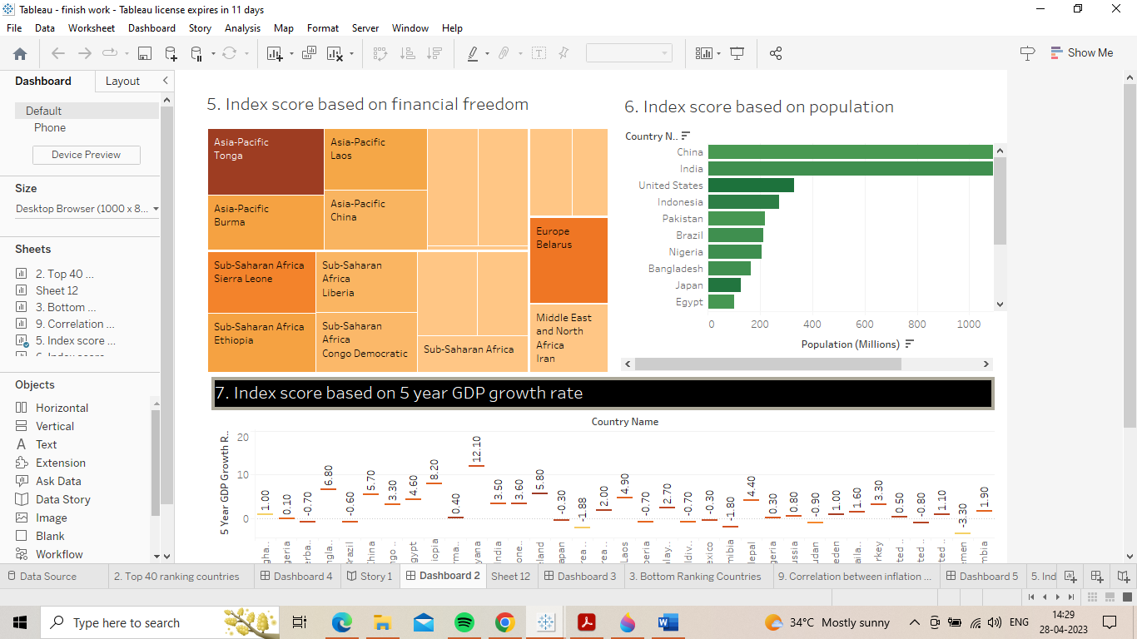

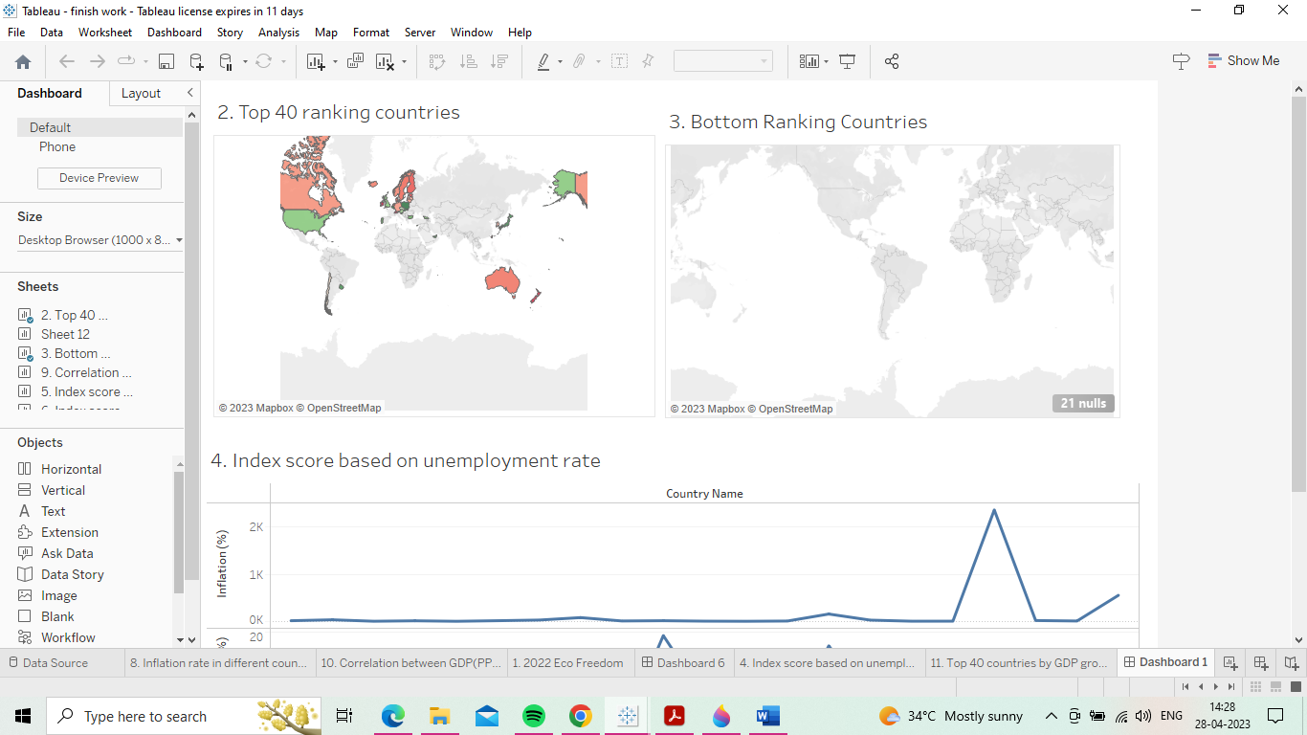

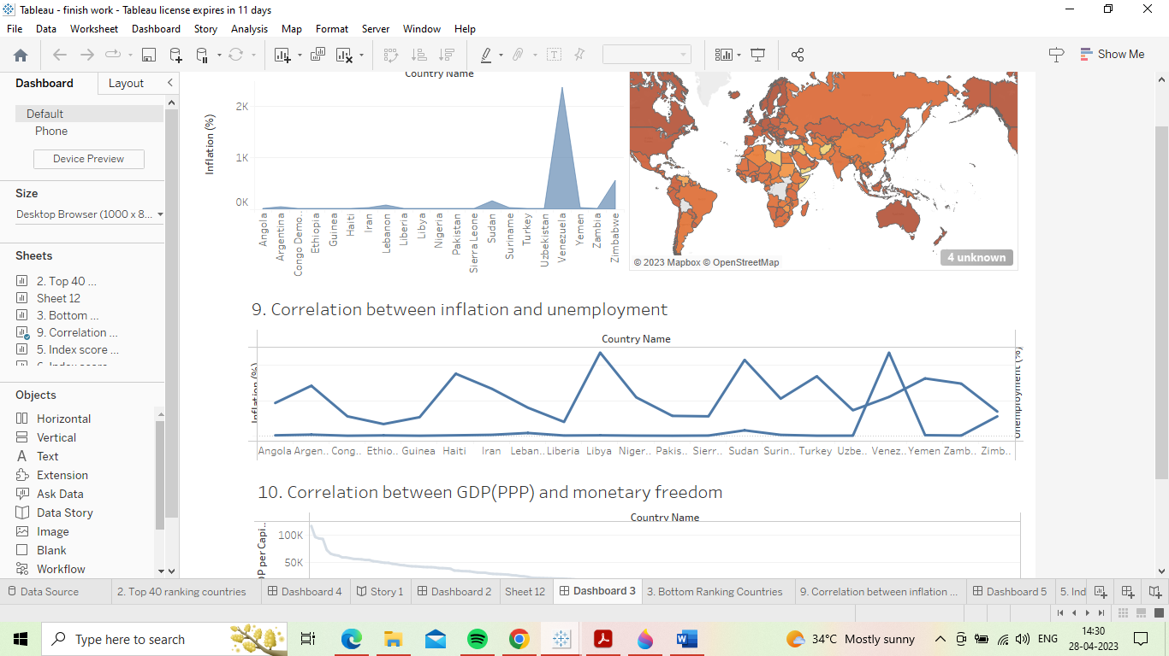

**ADVANTAGES:**

Free market economies allow business owners to innovate new ideas, develop new products and offer new services. Entrepreneurs need not depend on government agencies to tell them when the public needs a new product. They can study consumer demands, research popular trends and meet the customer's needs through innovation. Innovation also breeds competition among firms.

DISADVANTAGES:

The primary objective for any company in a free market economy is to make a profit. In many cases, companies may sacrifice worker safety, environmental standards and ethical behavior to achieve those profits. The early 2000s saw such unethical behavior run rampant at companies such as Enron and WorldCom. The Deepwater Horizon oil spill in 2010, one of the largest environmental disasters in U.S. history, was largely attributable to the use of substandard cement and other cost-cutting measures.

STORY:

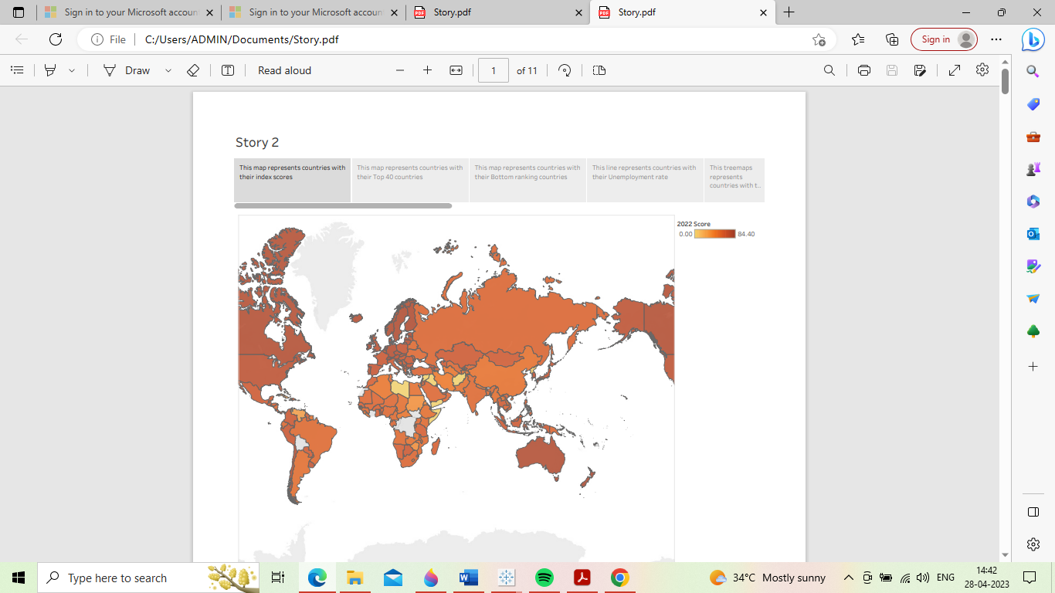

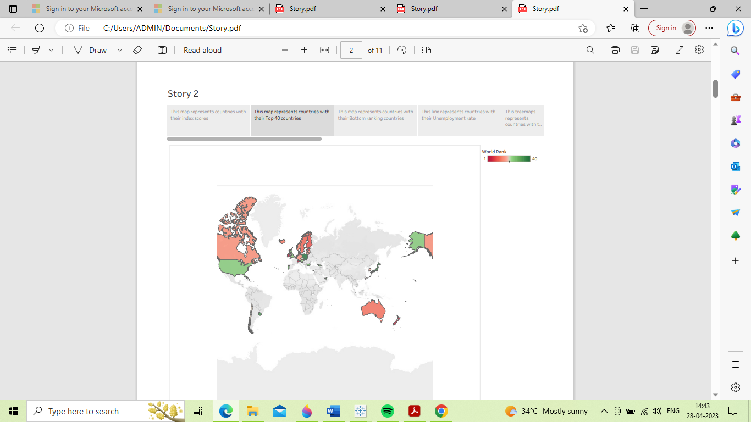

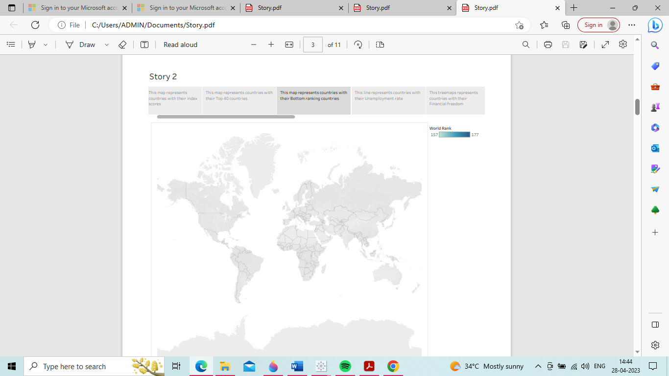

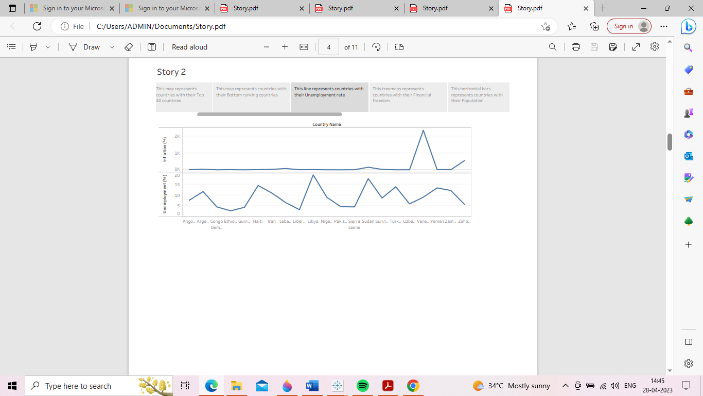

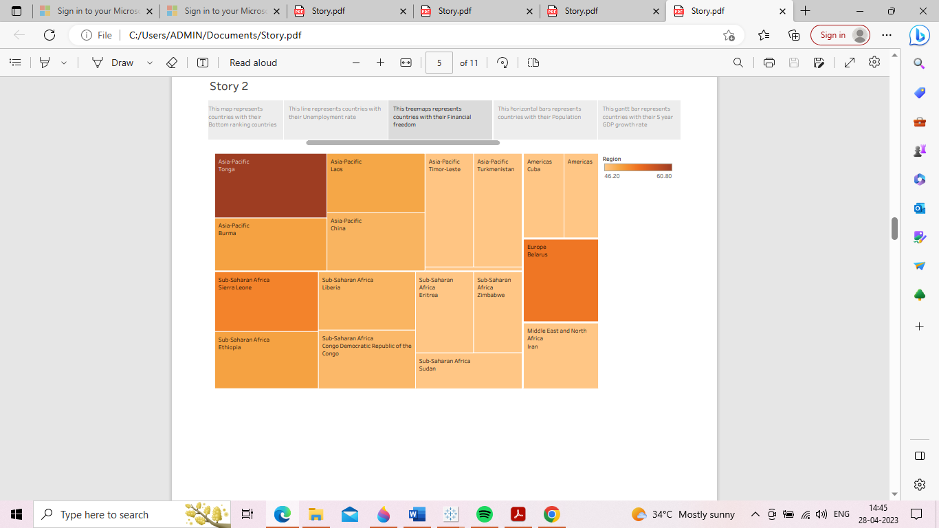

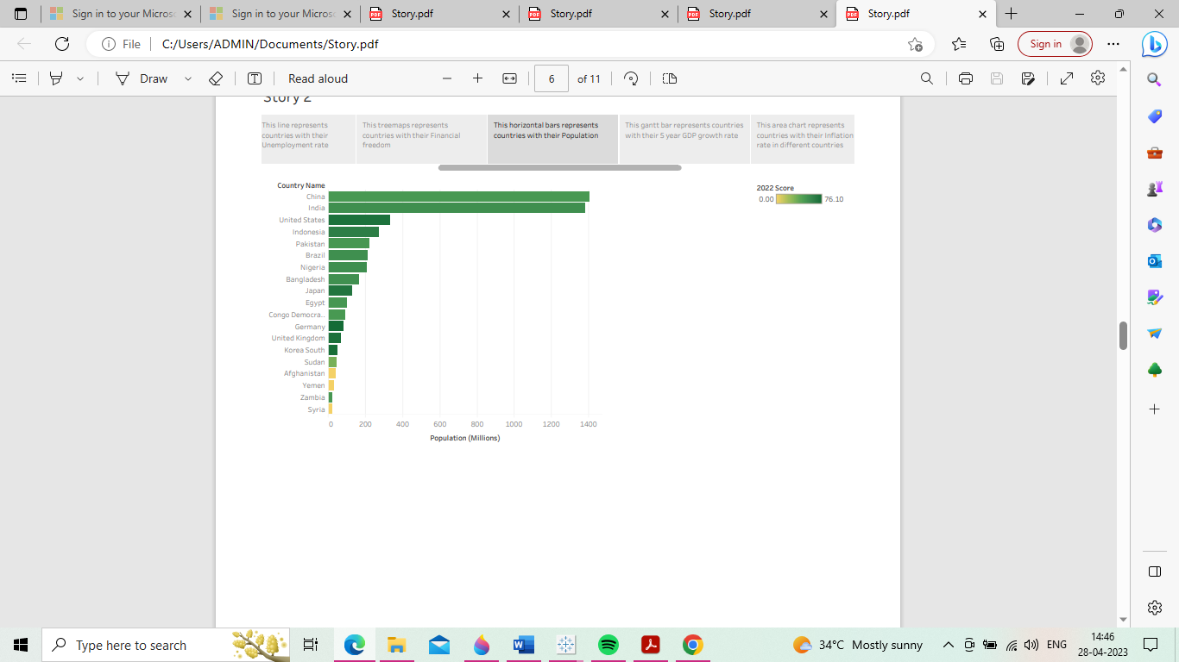

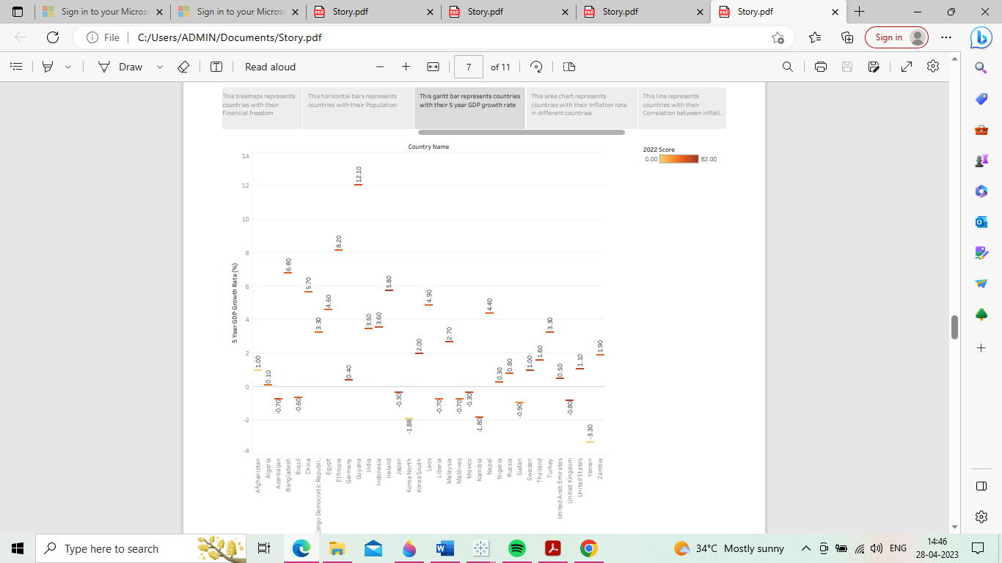

**EMPATHY MAP:**

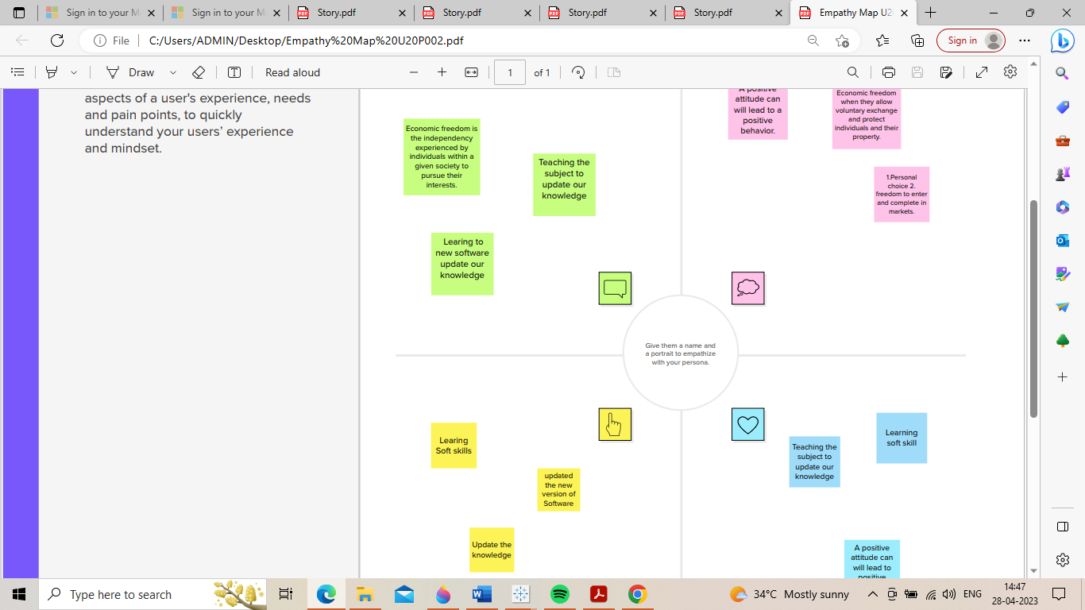

**CONCLUSION:**



Individuals have economic freedom when property they acquire without the use of force, fraud, or theft is protected from physical invasions by others and they are free to use, exchange, or give their property as long as their actions do not violate the identical rights of others.